HOMEWORK WORKFLOW ORCHESTRATION – WEEK 02

Question 1. Within the execution for Yellow Taxi data for the year 2020 and month 12: what is the uncompressed file size (i.e. the output file yellow_tripdata_2020-12.csv of the extract task)?
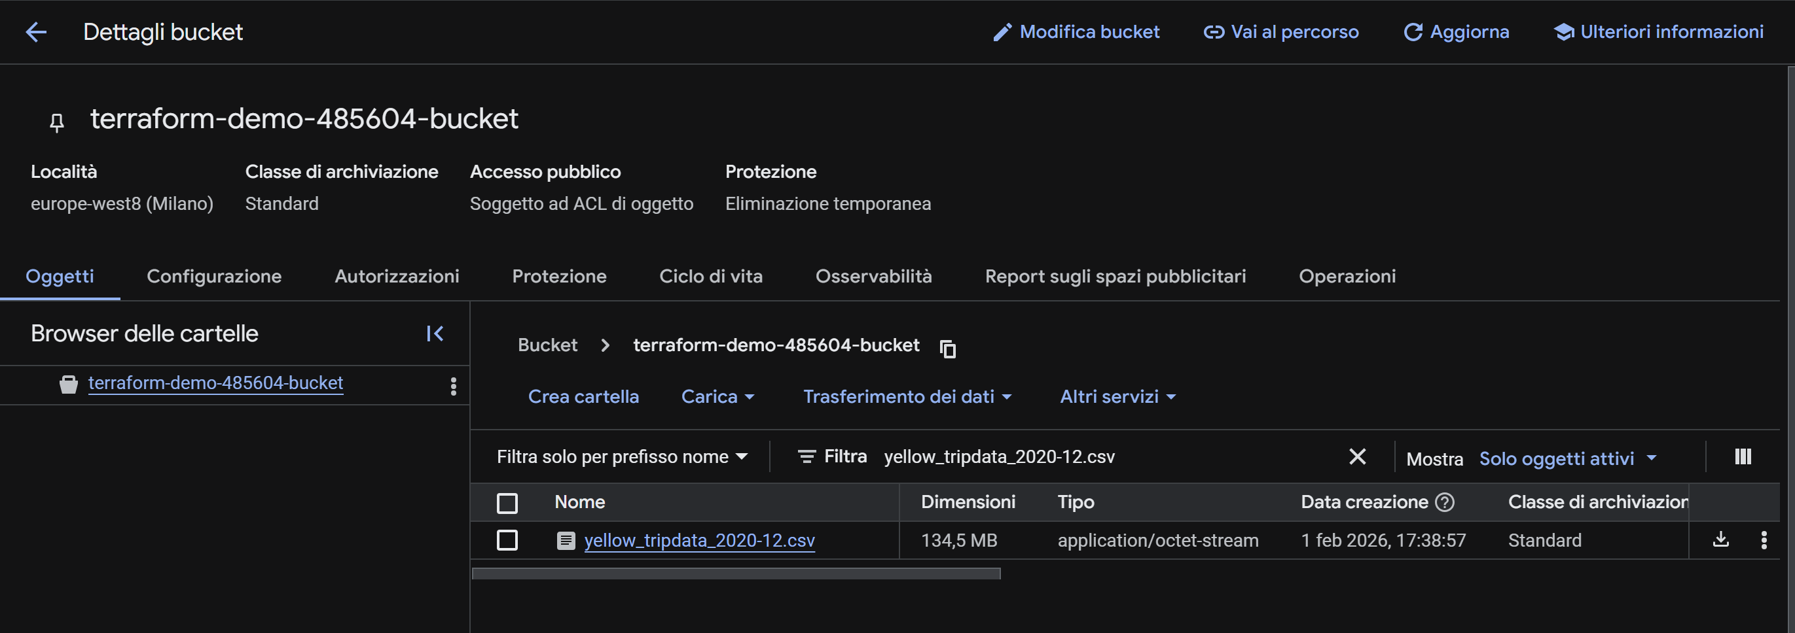

# Question 3. How many rows are there for the Yellow Taxi data for all CSV files in the year 2020?
SELECT count(1)
FROM `nodal-nirvana-485604-k6.DEZoocamp_demo_dataset.yellow_tripdata`
where filename like 'yellow_tripdata_2020%'
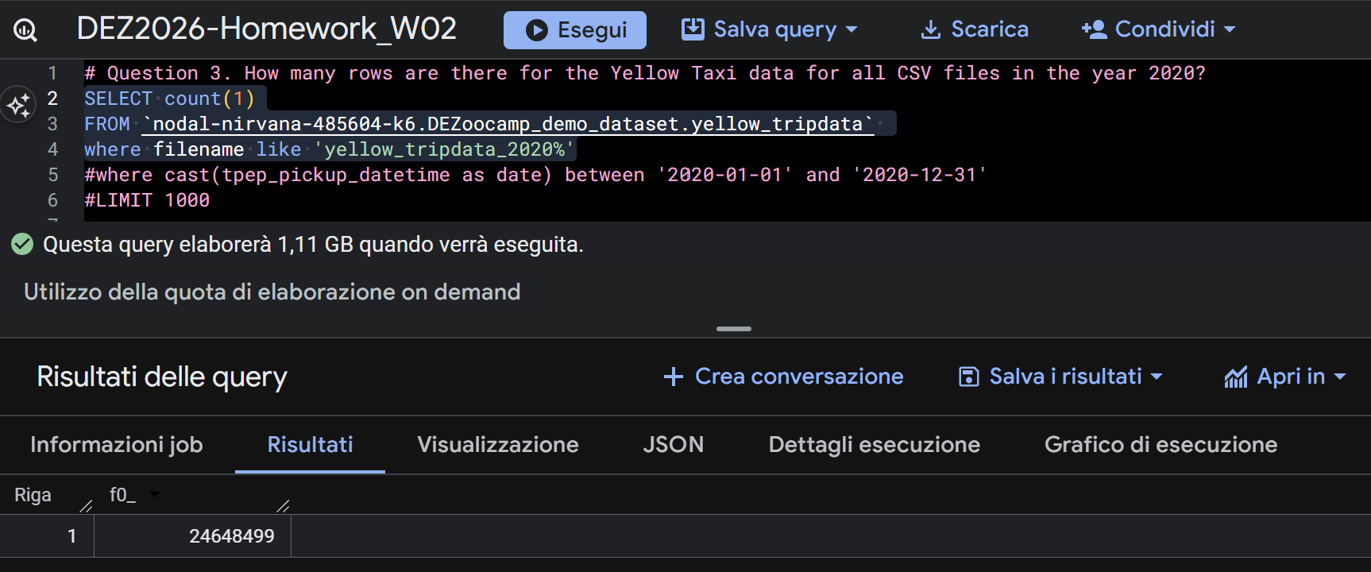

#Question 4. How many rows are there for the Green Taxi data for all CSV files in the year 2020?
SELECT count(1)
FROM `nodal-nirvana-485604-k6.DEZoocamp_demo_dataset.green_tripdata`
where filename like 'green_tripdata_2020%'
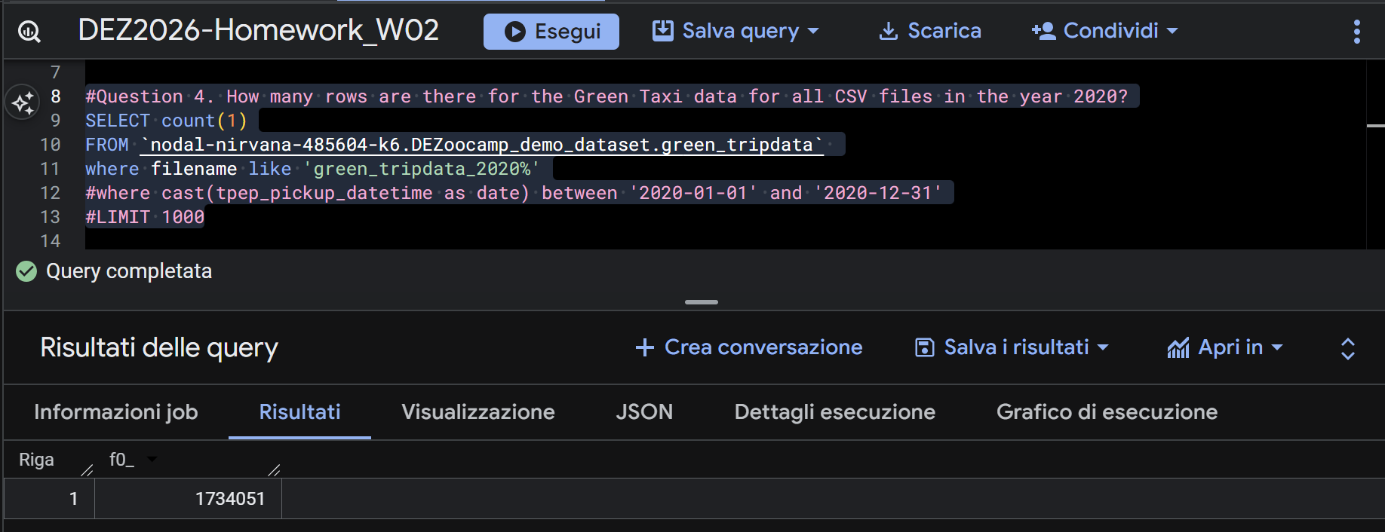

#Question 5. How many rows are there for the Yellow Taxi data for the March 2021 CSV file?
SELECT count(1)
FROM `nodal-nirvana-485604-k6.DEZoocamp_demo_dataset.yellow_tripdata`
where filename like 'yellow_tripdata_2021-03%'

